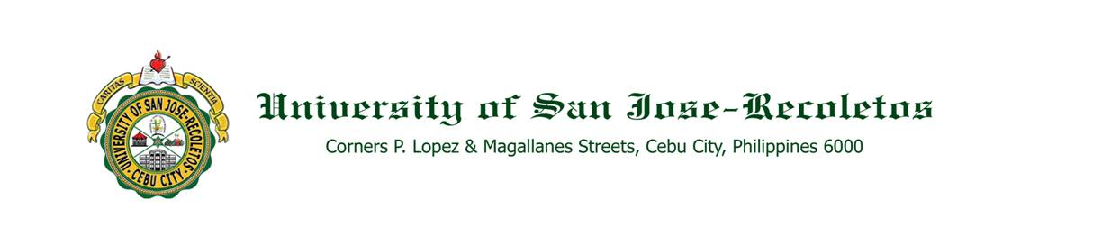

**OFFICE OF THE PRESIDENT**

**DATE : August 3, 2020**

**TO : Religious Administrators**

**Lay Administrators**

**Faculty Members**

**SUBECT : CONDUCT OF TRAINING NEEDS ANALYSIS SURVEY**

Greetings!

This is in connection with the use of an external provider for the University’s Learning Management System (powered by CAL-D2L’s Brightspace) for Academic Year 2020-2021. Please be advised that a training needs analysis survey shall be conducted as first step of the training program for the new LMS. This survey is aimed at determining literacy, assessing skills, and helping CAL craft customized training pathways for the different groups’ needs.

All concerned shall accomplish the training needs analysis through this link: [Training Needs Analysis as part of CAL EDISON](https://www.surveymonkey.com/r/5BYN7JV) not later than August 6, 2020.

Your support and cooperation in this regard shall be highly appreciated in order to deliver what is expected of us by the students.

Thank you.

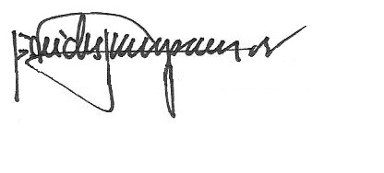

REV. FR. CRISTOPHER C. MASPARA, OAR

President